
A10
Sreenidhi Institute of Science and Technology
(An Autonomous Institution)
Code No: 101IT04/111IT04
B. TECH. III-Year I-Semester Examinations, December 2015 (Supplementary)
DESIGN AND ANALYSIS OF ALGORITHMS (CSE & IT)

Time: 3 Hours Max. Marks: 70

Note: No additional answer sheets will be provided.

Part - A
Max.Marks:20

Answer all QUESTIONS. EACH QUESTION CARRIES 2 MARKS.
1. Define the Big-oh, Big-omega notations.
2. What is amortized analysis?
3. What is the divide and conquer recurrence relation of Binary search?
4. Write about Hamiltonian cycle.
5. What are the properties of LC search?
6. Differentiate between deterministic and non deterministic algorithm.
7. Analyze the time complexity of the following segment:
for(i=0;i<N;i++)
for(j=N/2;j>0;j--) sum++;
8. Write the difference between the Greedy method and Dynamic programming.
9. What is traveling sales man problem?
10. What is LC branch and bound?
Part – B
Max.Marks:50

ANSWER ANY FIVE QUESTIONS. EACH QUESTION CARRIES 10 MARKS.
- a) Write briefly about Stranssen’s matrix multiplication.
b) What are little asymptotic notations? What are their significance?

2. Write and explain the merge sort algorithm based on divide and conquer method. Derive its time and space complexity.

- a) Write an algorithm of Krushkal's minimum cost spanning tree.
b) Find the shortest path from s to t of the following graph by using single source shortest path.

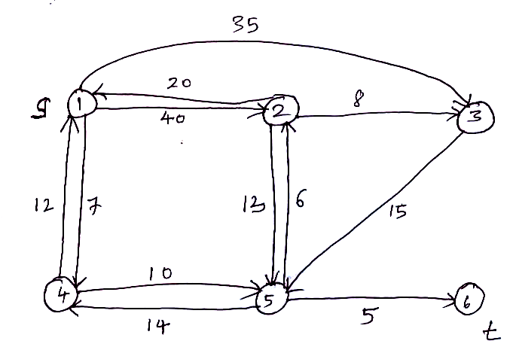

- a) Write an algorithm of optimal binary search tree.
b) Find the shortest path between all pairs of nodes in the following graph by using dynamic programming.
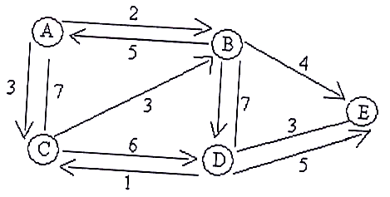

5. a) Define Backtracking. Draw the search space for solution of 4-queens problem.
b) Differentiate between FIFO Branch and bound and LC Branch and bound.

6. a) State cook’s theorem and explain.
b) Explain Deterministic algorithms with example.

7. a. Explain the following :
i) Graph coloring
ii) Hamiltonian cycle.

b. A complete undirected graph ‘G’ is given on the vertex set { 0, 1, 2… n-1} in any fixed ‘n’, draw the minimum spanning of G if weight of edge ( U,V) is | U - V | ?

8. Write short notes on the following:
a. Probabilistic Analysis.
b. NP-Hard and NP-Complete problems.

-- 00 -- 00 –

